UNIT – II
PART – A

- What are the differences between elemental semiconductors and compound semiconductors?
Elemental semiconductors | Compound semiconductors
They are made of single element. e.g. Ge, Si | They are made of single element. e.g. GaAs, Gap
Heat is produced due to recombination | Photons are emitted during recombination
current amplification is more | current amplification is less

- Write an expression for carrier concentration of holes in the valence band of p-type semiconductor.
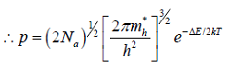
- Draw the diagram to show variation of Fermi level with temperature in the case of p-type semiconductor for high and low doping level.
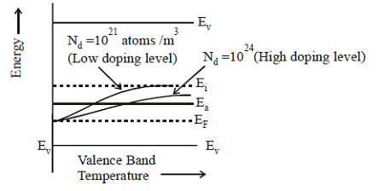

- What is covalent bond? Give the structure of a crystal having this bond.
A covalent bond is a chemical link between two atoms in which electrons are shared between them.
Diamond:
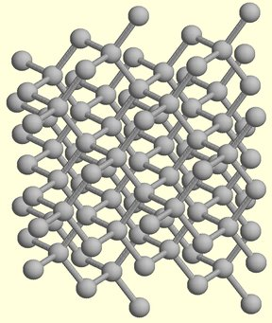

- What is effective mass of an electron?
The effective mass is a quantity that is used to simplify band structures by constructing an analogy to the behavior of a free particle with that mass.
- Distinguish between n-type and p-type semiconductors.
n type semiconductors | p type semiconductors
It is obtained by doping an intrinsic semiconductor with pentavalent impurity. | It is obtained by doping an intrinsic semiconductor with trivalent impurity
It has donor energy level is very close to conduction band | It has acceptor energy levels very close to valence band.

- Sketch the Fermi energy level of an intrinsic semiconductor.
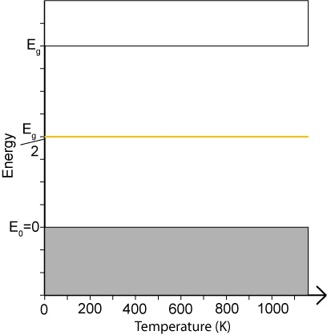

- Given an extrinsic semiconductor , how will you find whether it is n-type or p-type.
By using hall coefficient R_{H} if it is positive then it is p-type and R_{H} is negative then it is n-type semiconductor.

- Write an expression for electrical conductivity of an intrinsic semiconductor.
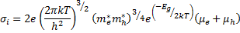

- Draw the graph for variation of Fermi level with temperature in p-type semiconductor.
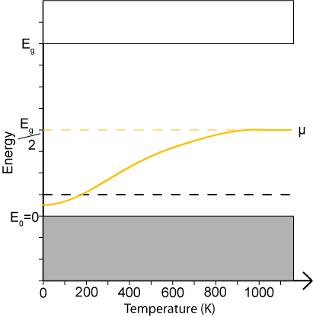

PART – B

1. Derive and expression for carrier concentration in an intrinsic semiconductor. 16
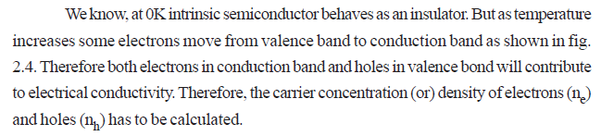
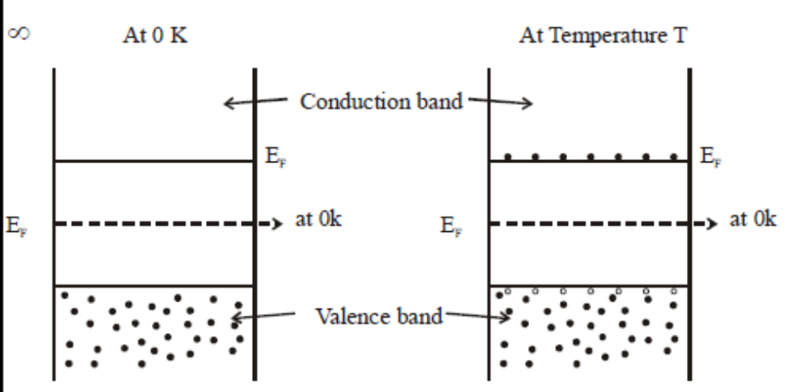
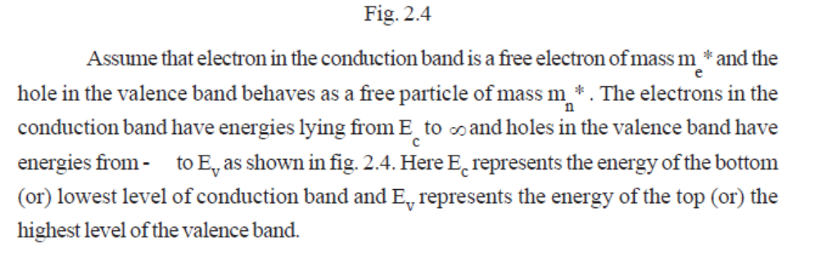
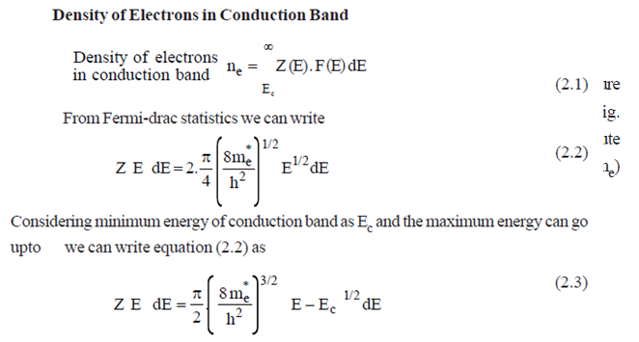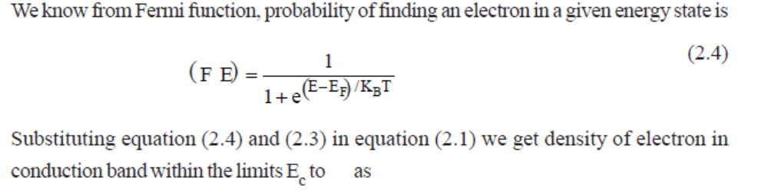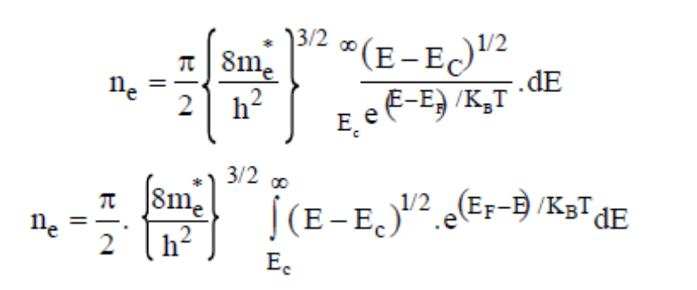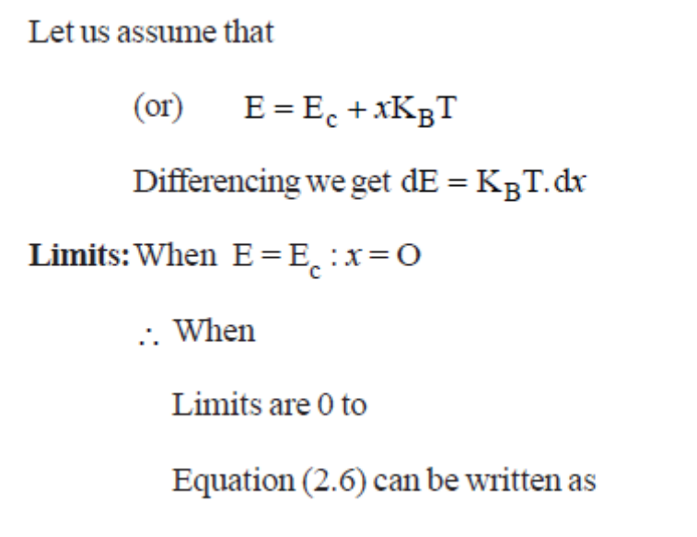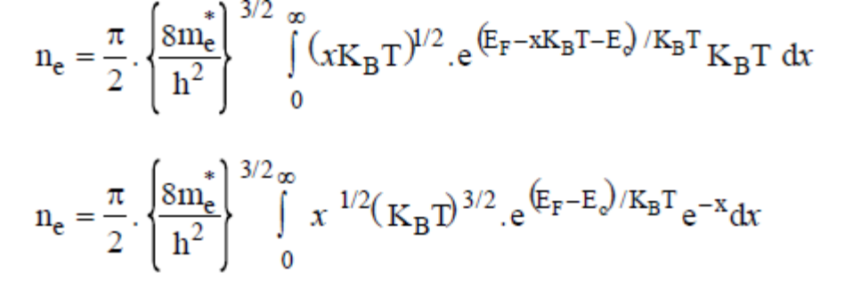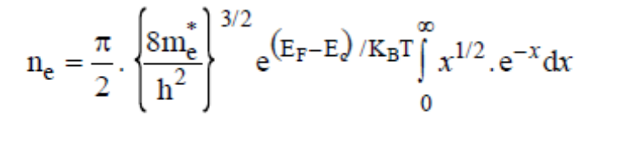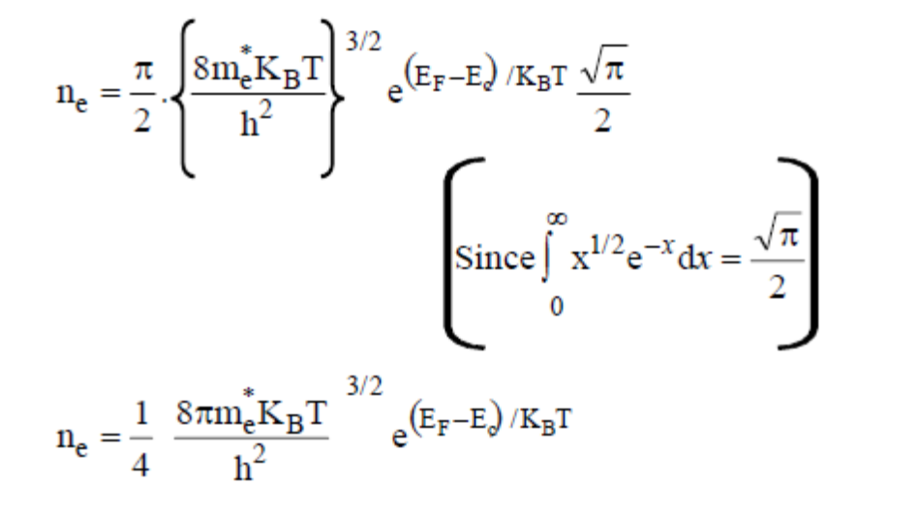
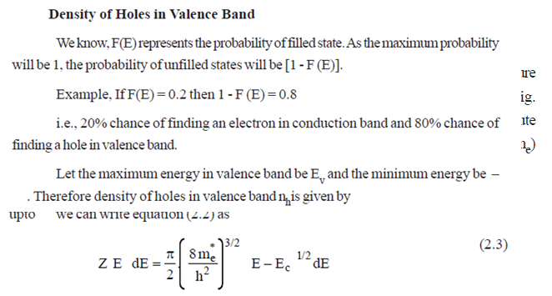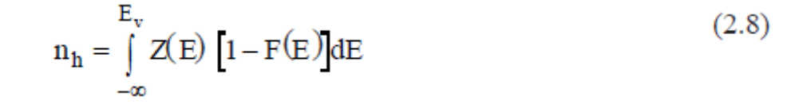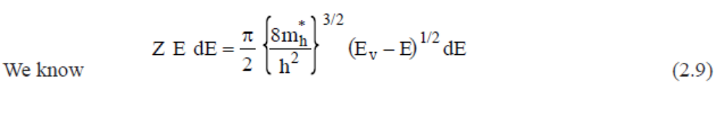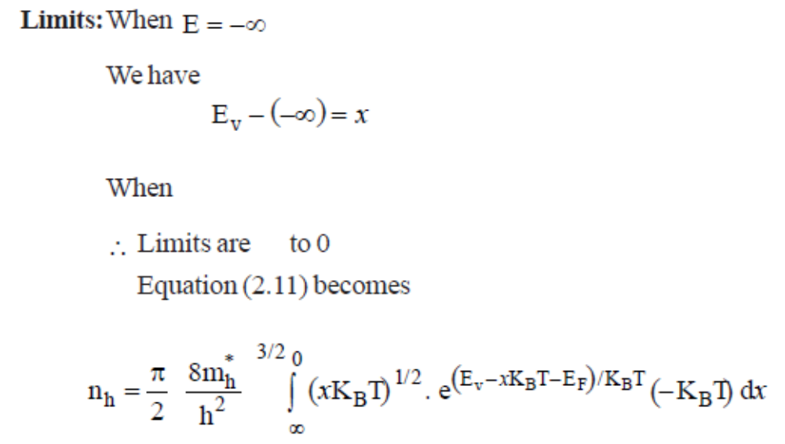
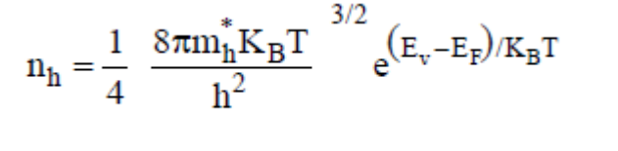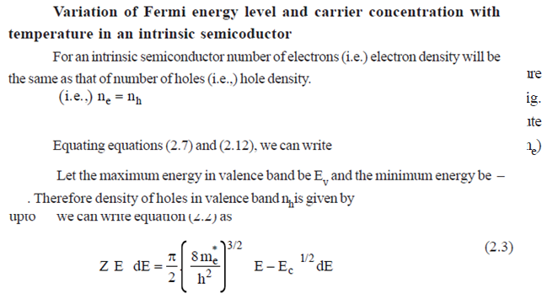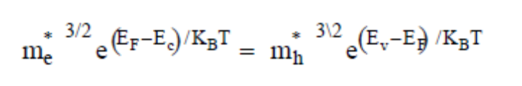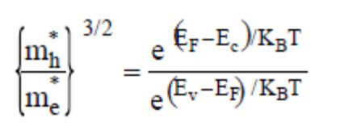ne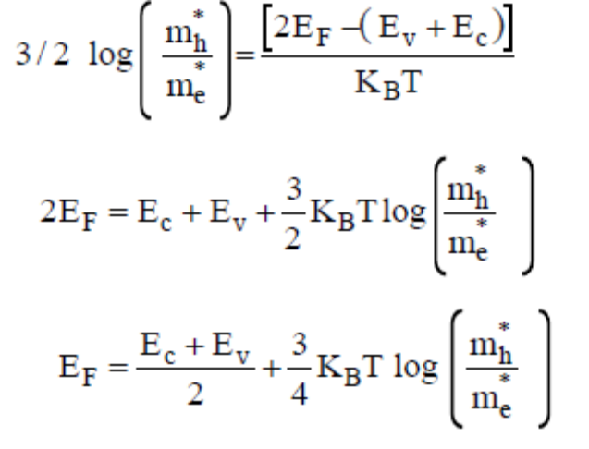
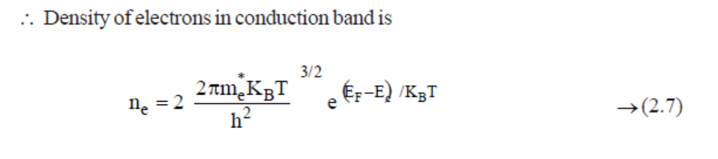
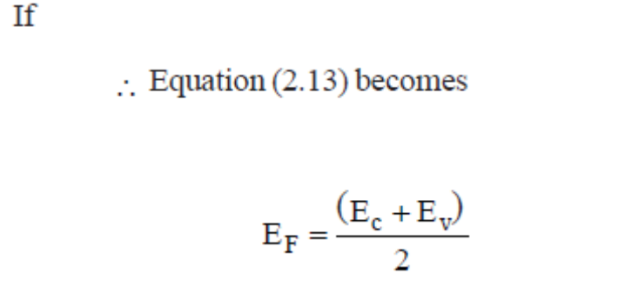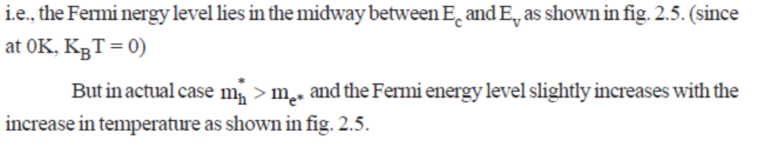

2. i) Derive an expression for the electrical conductivity of an intrinsic semiconductor. 6
We know that
Electrical conductivity of a semiconductor due to electrons is
(1)
n is number of electrons per unit volume
e is charge of an electron (1.6 X 10⁻¹⁹ C)
Similarly (2)
Electrical conductivity of semiconductor σ_{i}= σ_{e}+ σ_{h} (3)
Substitute equation (2) & (3) in equation (3)
σ_{i}=e(nµ_{e}+pµ_{h}) (4)
In intrinsic semiconductor n=p=n_{i}
σ_{i}=e(n_{i}+n_{i})
σ_{i}=e n_{i} (+) (5)
σ_{i}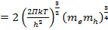 e(µ_{e}+ µ_{h})
σ_{i}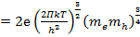 (µ_{e}+ µ_{h}) (6)
So electrical conductivity depends upon the negative exponential of the forbidden gap and also mobilities of an electron and holes

ii) Discuss the variation of Fermi level with temperature in an intrinsic semiconductor. 6
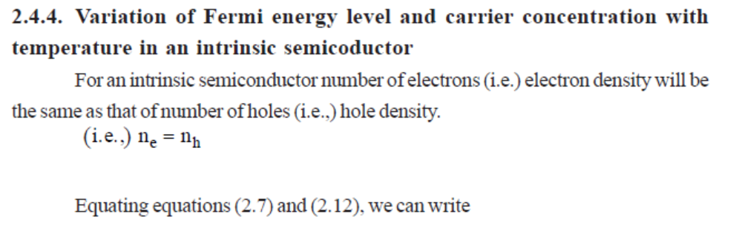
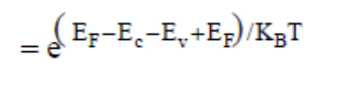
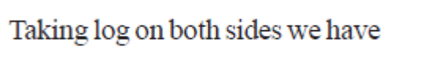
iii) How will you determine the energy gap of an intrinsic semiconductor? 4
Taking log on both sides
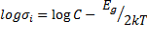
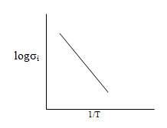

Determination of E_{g}:
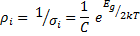
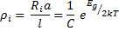
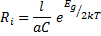
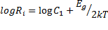
This is similar to the equation of a straight line, whose slope is given by 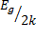
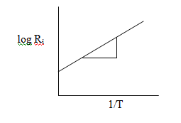

Therefore E_{g} = 2k x slope.

3. i) Derive expressions for carrier concentration and Fermi energy in a n-type semiconductor. 10
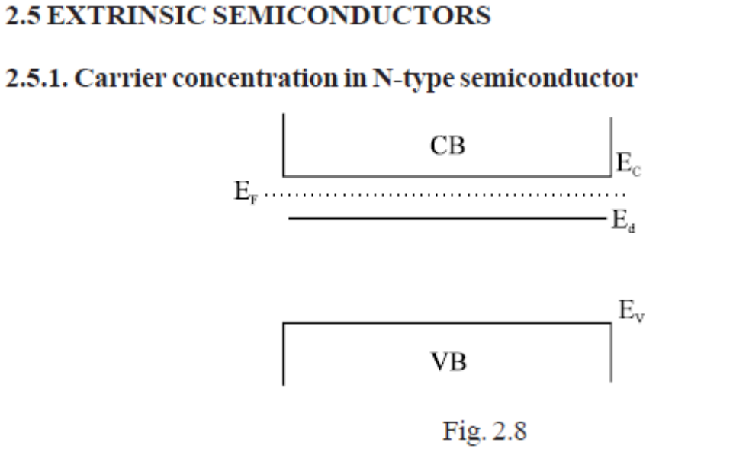
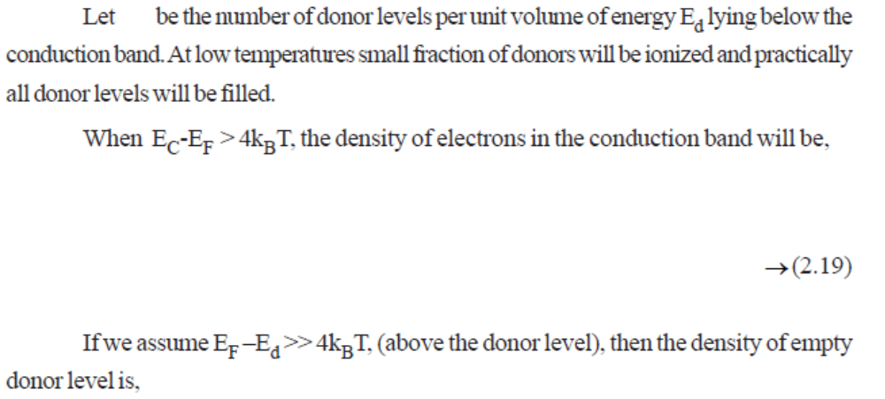

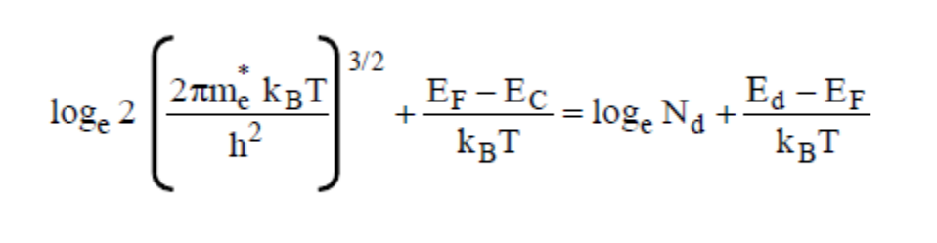
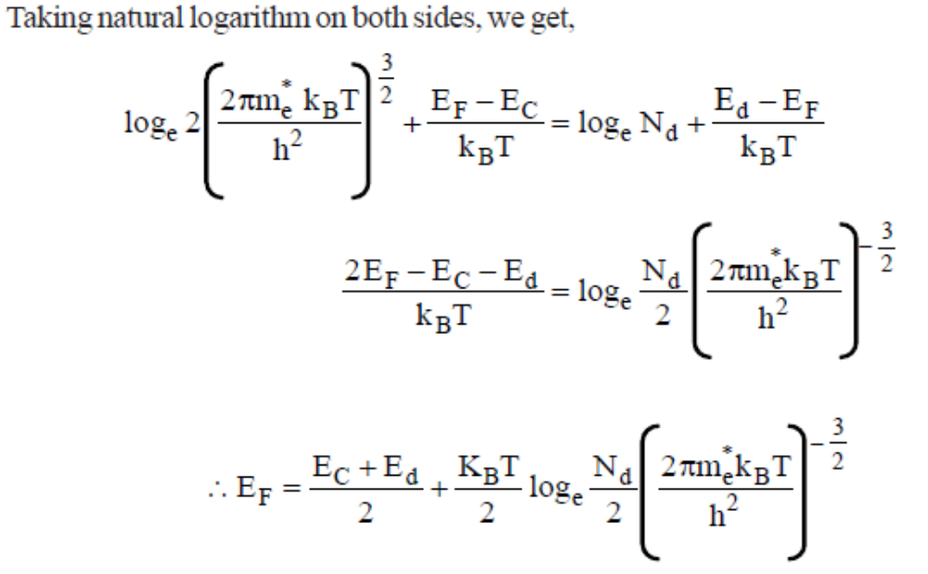
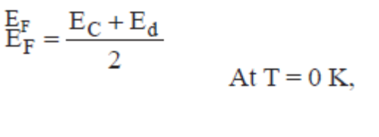
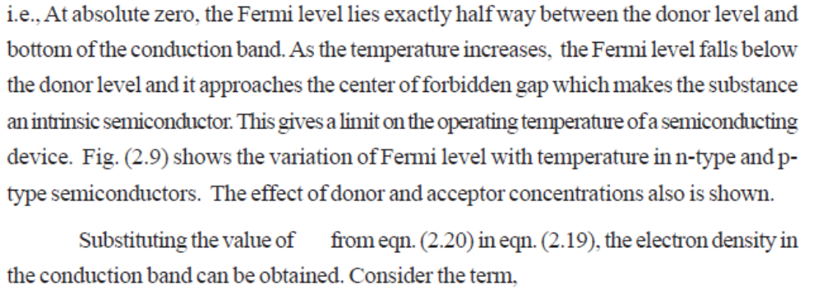
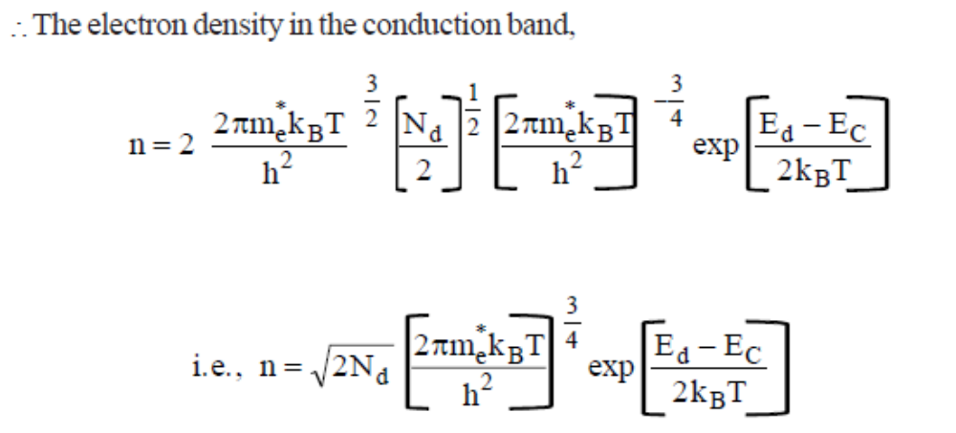
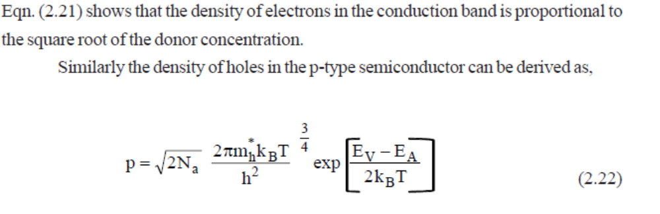

ii) Explain the variation of Fermi level with temperature and donor impurity concentration. 6
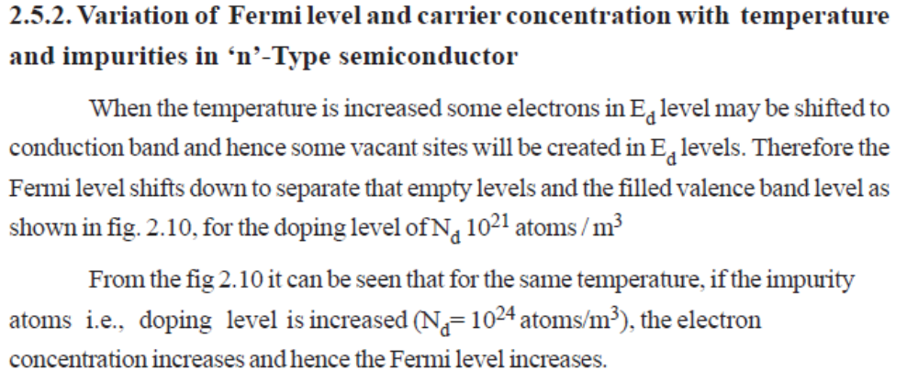
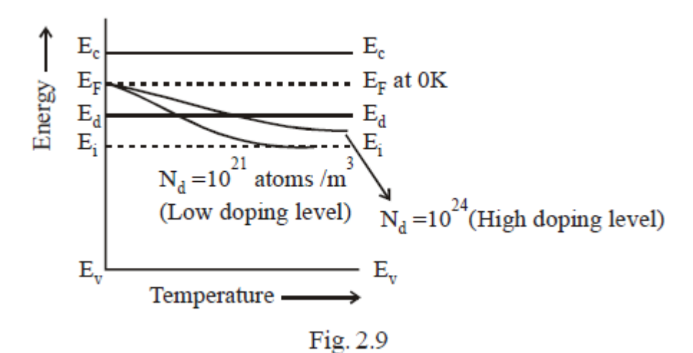

4. i) Derive expressions for carrier concentration and Fermi energy in a p-type semiconductor. 10
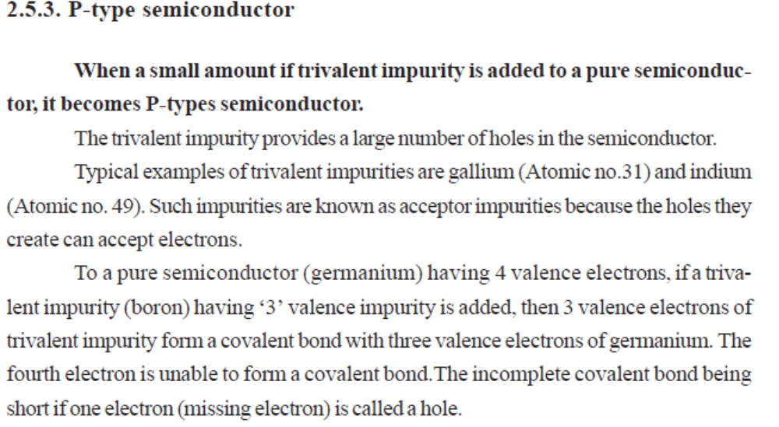
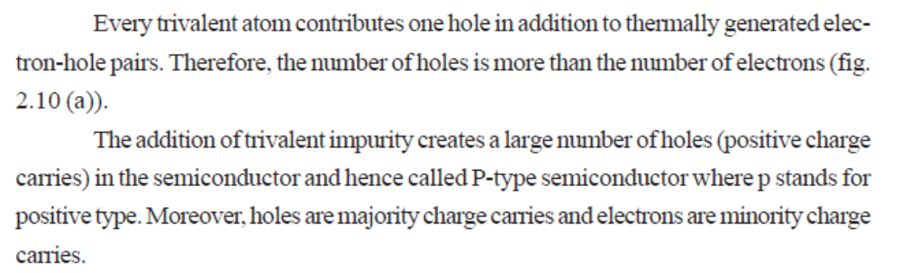
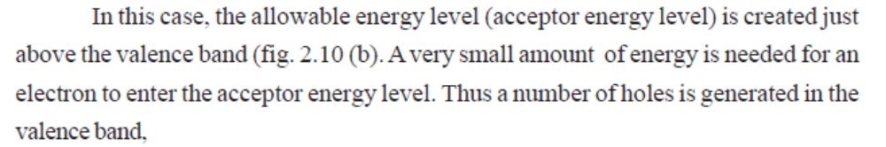
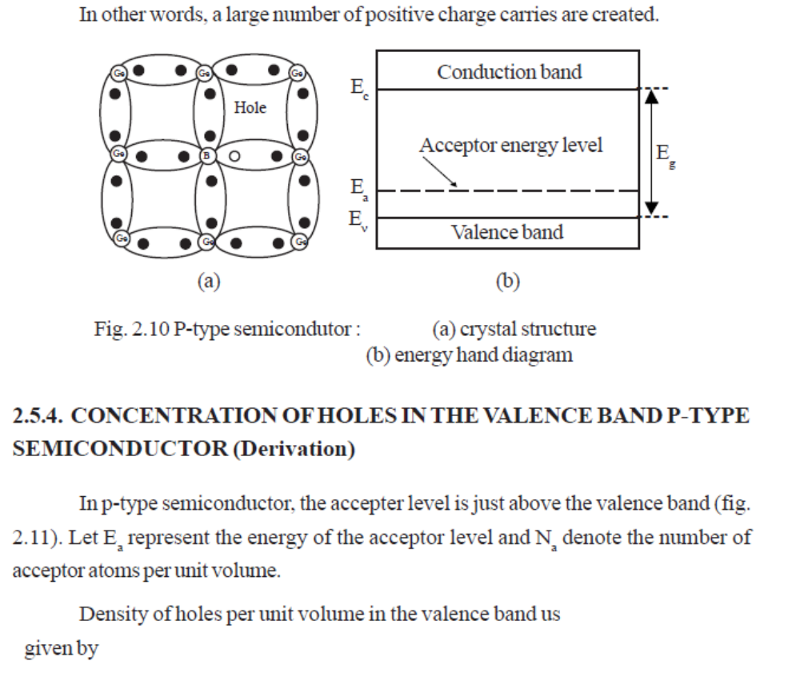
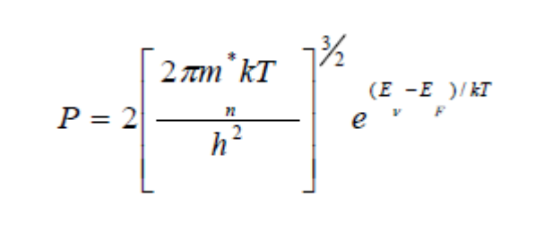
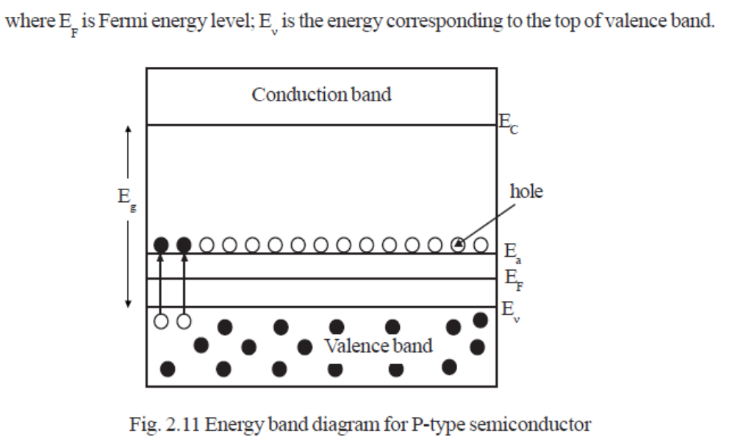
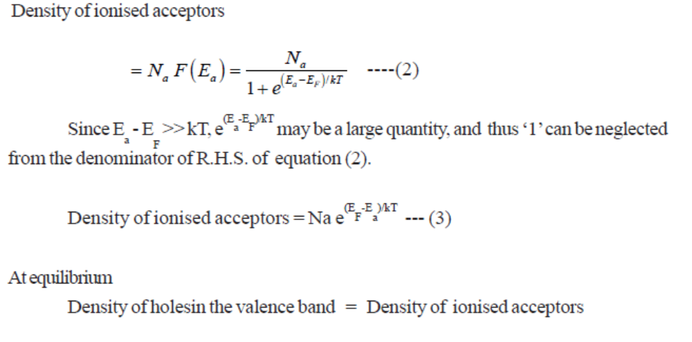
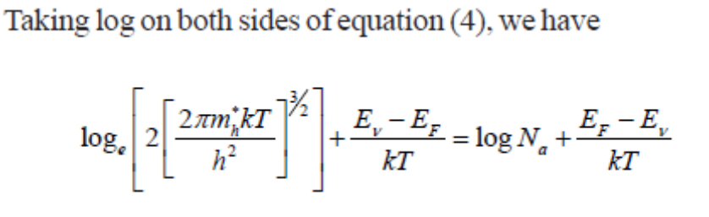
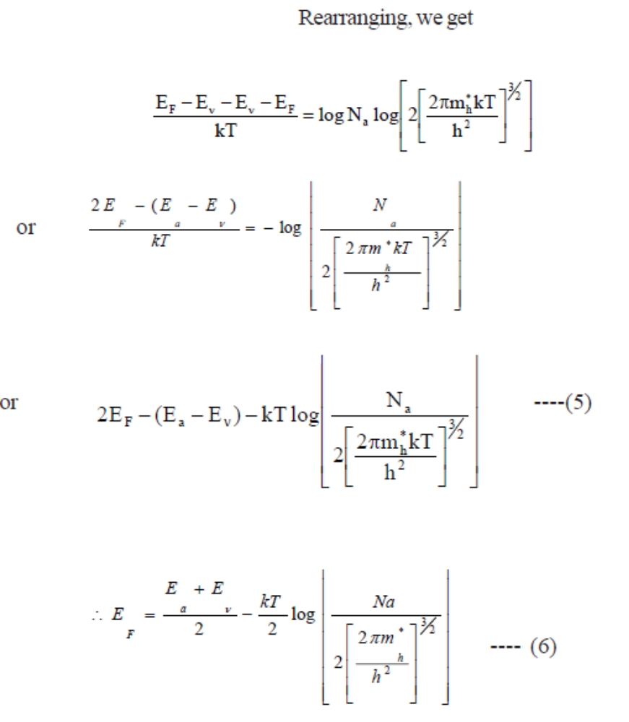
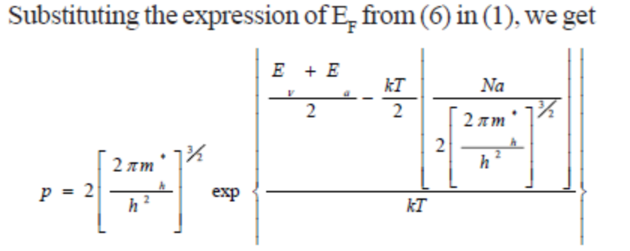
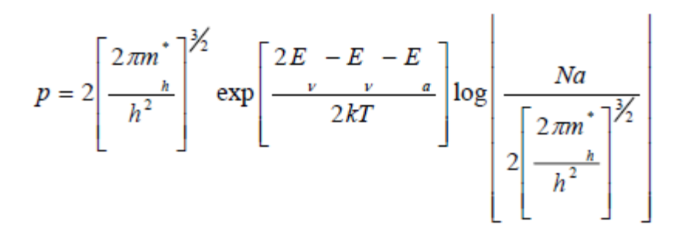
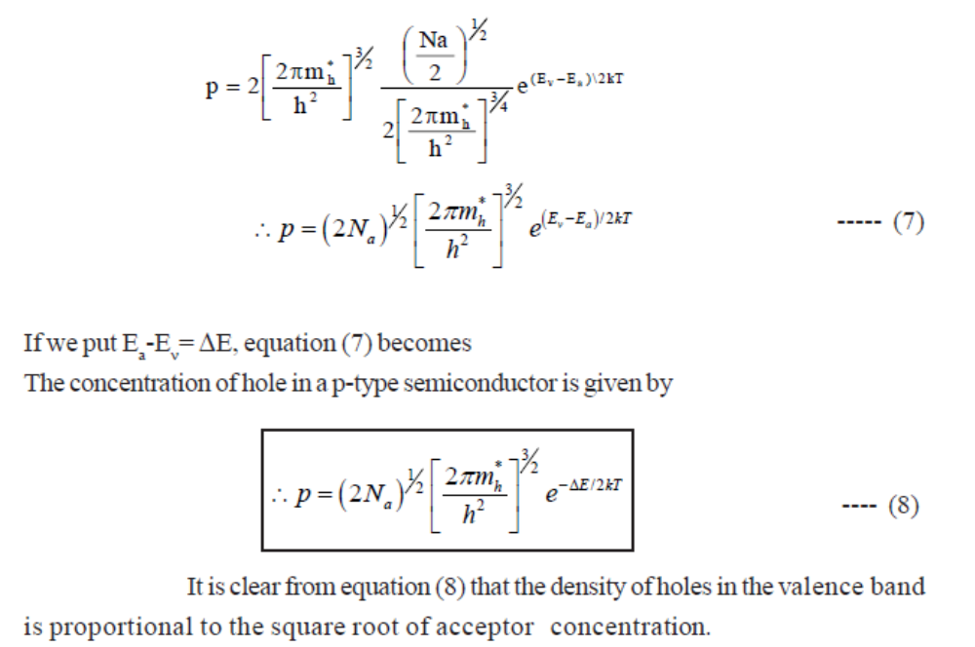

ii) Explain the variation of Fermi level with temperature and acceptor impurity concentration. 6
When the temperature is increased,some of the electrons in the valence band will go to acceptor energy levels by breaking up the covalent bonds and hence the Fermi energy level is shifted in upward direction for doping level N_{d}=10²¹ atoms/m³ as shown figure.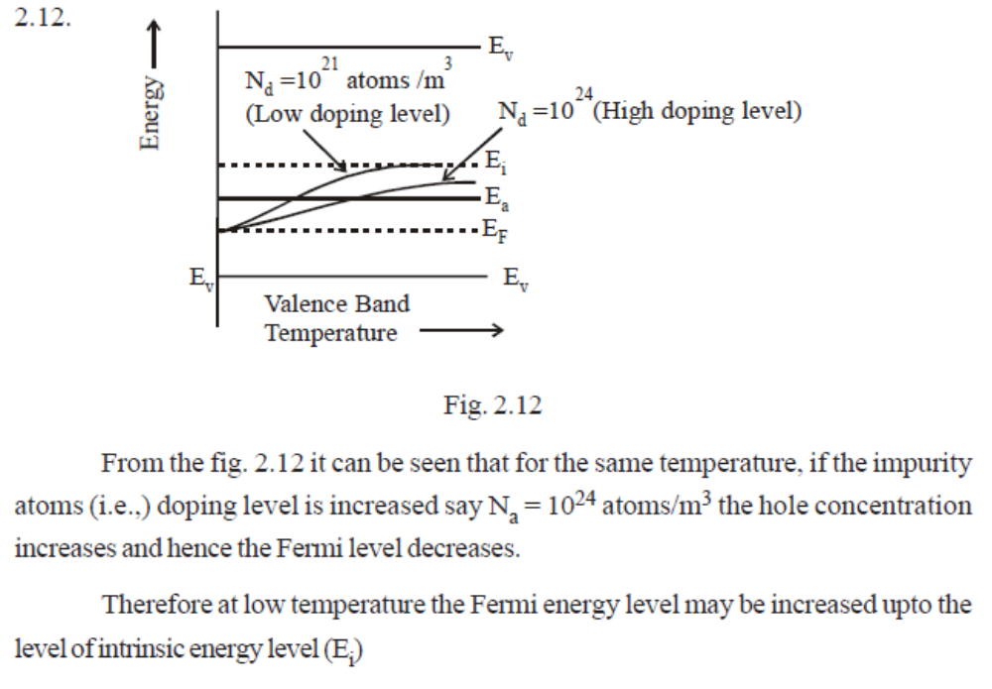

5. i) How does the carrier concentration and electrical conductivity vary with temperature in an
extrinsic semiconductor? Explain. 8
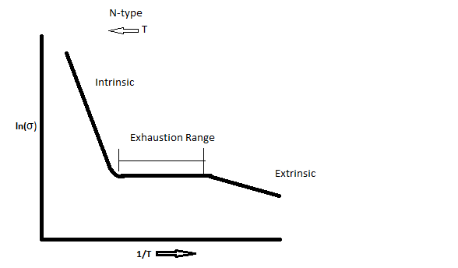

At low temperatures, the charge carriers are mainly due to the impurity atoms. The low temperature is sufficient to form electrons in the conduction band from the donor levels in n-type semiconductors. This region, where the charge carriers are due to impurity atoms is called extrinsic or impurity range.
As temperatures increase, all the electrons in the donor levels are ionized and no more additional electrons are obtained for a certain range of temperatures, as the temperature is not sufficient to move electrons from valence band to the conduction band. Here the carrier concentration is nearly constant and this region is called exhaustion region.
When the temperature increases the electrons from the valence band move to the conduction band forming electron hole pairs. This mechanism is identical to the working of an intrinsic semiconductor and this region is called intrinsic range.

ii) The energy gap of Si is 1.1 eV. Its electron and hole mobilities at room temperature are
0.48 and 0.013 m² /V-s. Evaluate its conductivity. 8

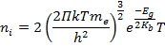
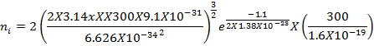
= 1.4707X10¹⁶ m⁻³
σ_{i}=e n_{i} (+)=1.4707X10¹⁶X1.6X10⁻¹⁹X(0.48+0.013)=1.160X10⁻³ Ω⁻¹m⁻¹

6. i) What is Hall effect? Explain Hall effect in p - type and n- type semiconductors. Derive an
expression for Hall coefficient. 2+6+4
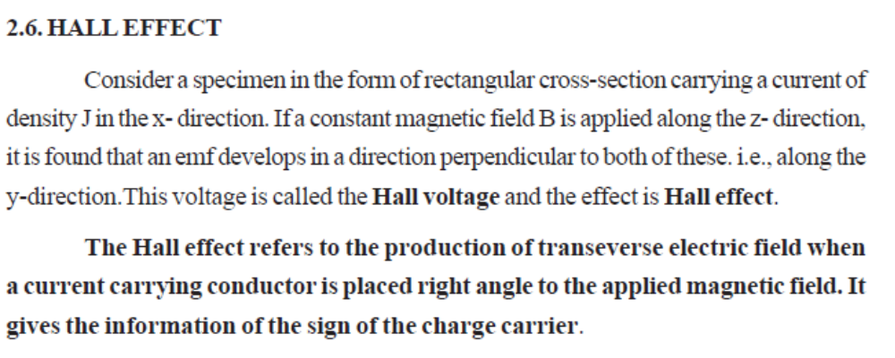
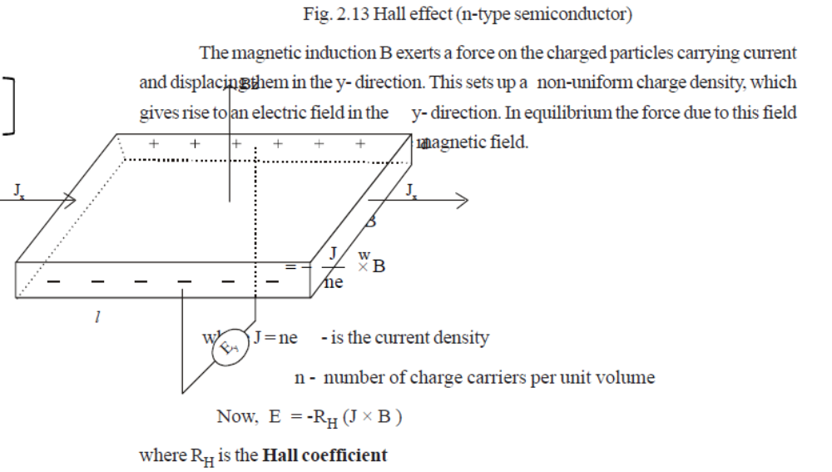
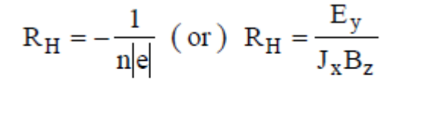
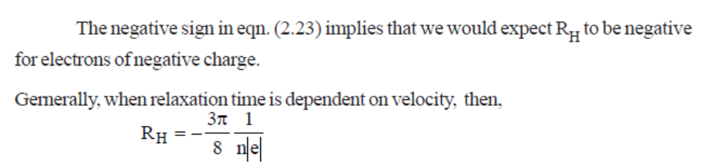
ii) Describe the experimental setup for the measurement of Hall voltage and give its
applications. (4)
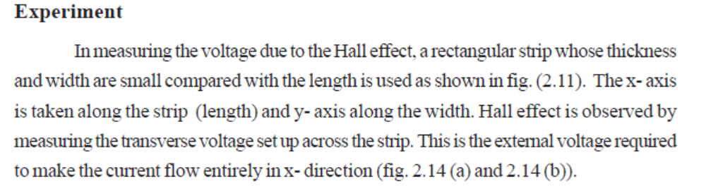
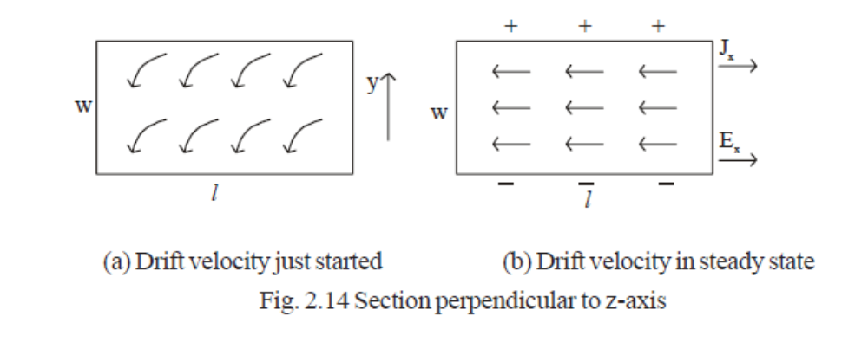
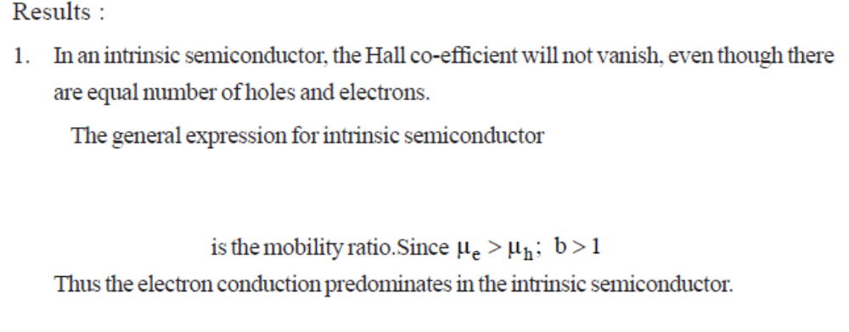
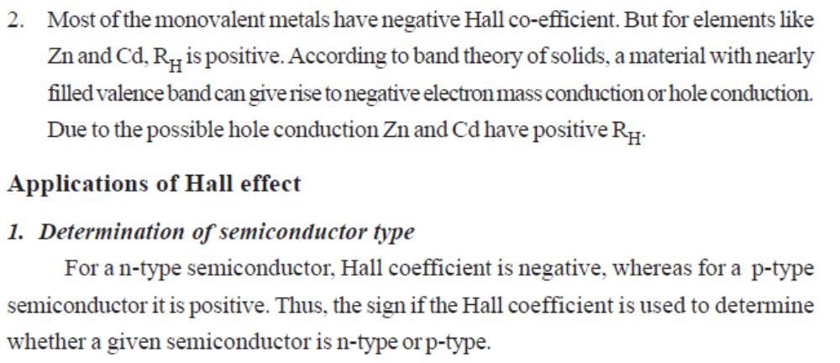
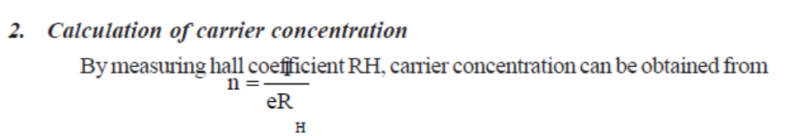
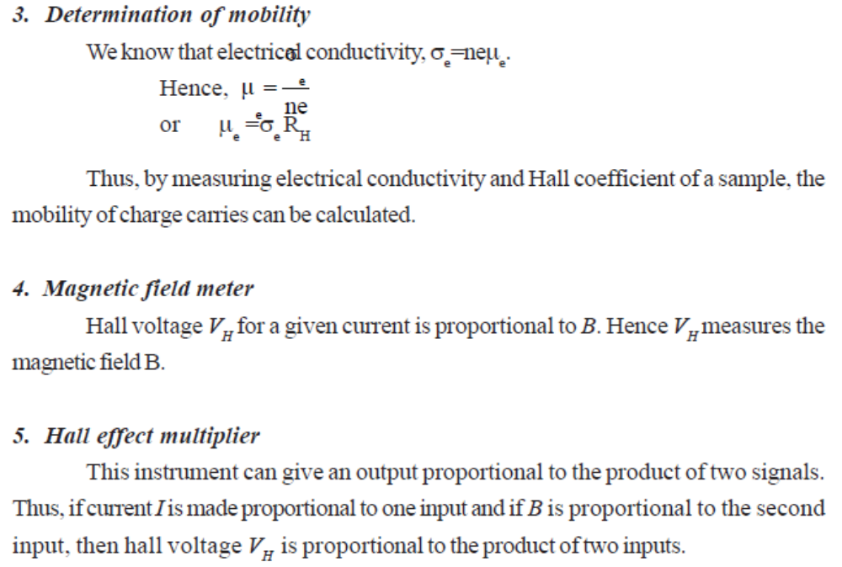

7. i) A magnetic flux density of 0.5 Wb/m² is applied from front to back, perpendicular to largest
faces of a specimen. A current of 20 mA flows lengthwise and the voltage measured across
its width is 37 µV. The specimen is 12 mm long, 1 mm wide and 1 mm thick. Find the Hall
coefficient. 5
R_{H} = V_{H} b / I_{H} B = 37x 10⁻⁶ x 1 x 10⁻³ / 20x10⁻³x0.5 = 3.7 x 10⁻⁶ C⁻¹m³
N = 1.18 / e R_{H} = 1.18/1.609x10⁻¹⁹ x 3.7 x 10⁻⁶ = 1.98 x10 ²⁴ / m³
ii) Explain how a semiconducting material can be classified into p-type and n-type
semiconductor using Hall coefficient. 5
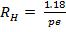 and it is positive value for holes
and it is negative value for electrons
iii) The donor density of an n-type germanium sample is 10 ²¹ / m³. The sample is arranged
in a Hall experiment having the magnetic field of 0.5 tesla and its current density is 500
A/m².Find the Hall voltage if the sample 3mm wide. 6
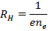
= =6.25X10⁻³
Hall Voltage V_{H} = R_{H}J_{X}Bt=6.25X10⁻³X500X0.5X3X10⁻³=4.6875X10⁻³ volts

8) i)Calculate the intrinsic carrier concentration of charge carriers of Ge at 300 K.E_{g} for Ge is 0.67 eV.Given = 0.012 and = 0.28 8
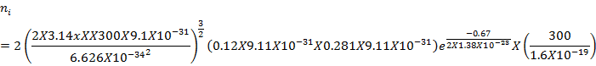
= 4.69X10¹⁸ m⁻³

ii) The mobility of electrons and holes in a sample of intrinsic semiconductor Ge at 300 K are 0.36 m²v⁻¹s⁻¹ and 0.17 m²v⁻¹s⁻¹ respectively. Find the forbidden energy gap if the resistivity of the specimen is 2.12 Ωm. 8

= and 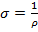 = = 0.47 Ω⁻¹m
= 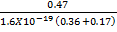 = 5.5 X10¹⁸ m⁻³

